**EXPERIMENT-3**

**RC High and Low Pass Circuits for Square Input**

-----------------------------------------------------------------------------------------------------------------------------------------------------------------------------------------------------------------------------------------------------------------------------------------------------------------------------------------------

1. Design a High pass and low pass RC circuit for a given cut off frequency.
2. Verify the condition for which the High pass circuit acts as a differentiator.
3. Verify the condition for which the Low pass circuit acts as an integrator.
4. **Aim:**
5. **Specification:** Cutoff Frequency of the Circuit = 1.60 kHz.
6. DRB
7. Capacitors:0.1µF
8. CRO
9. DSO Probes
10. Function Generator
11. Bread board
12. **Hardware:**
13. **Theory:**

**RC High Pass Circuit as a differentiator:**

The Differentiator circuit converts or 'differentiates' a square wave input signal into high frequency spikes at its output.

In an RC circuit if we take the voltage drop across R, and if we keep RC time constant is very short compared to the time period of the input waveform we will be differentiating the square wave.

**RC Low Pass Circuit as a integrator:**

The Integrator is a circuit that converts or ‘integrates' a square wave input signal into triangular waveform output.

In an RC circuit if we take the voltage drop across C, and if we keep RC time constant is very large compared to the time period of the input waveform we will be integrating the square wave.

1. **Procedure:**
2. Connect the circuit as per the circuit diagram
3. Apply Sine Wave with 5Vpk and 1.6KHz frequency using function generator and note down the /p and o/p voltages and plot Frequency Response.
4. Apply 5Vpk with 1.6 KHZ frequency using function generator , initially keep R small, slowly increase the R Value.
5. Observe the output in CRO.
6. Note the output wave form and calculate Rise and Fall Time for the different time constants: τ = T, τ >>T and τ <<T in Observation Table.
7. **Design:**

$Fc=\frac{1}{2πRC}$

C=0.1µF, R~=1KΩ, Fc = 1.60 KHz

1. **Frequency Response:**

**High Pass RC Circuit**

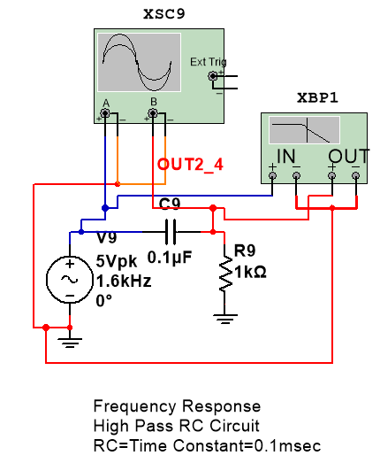

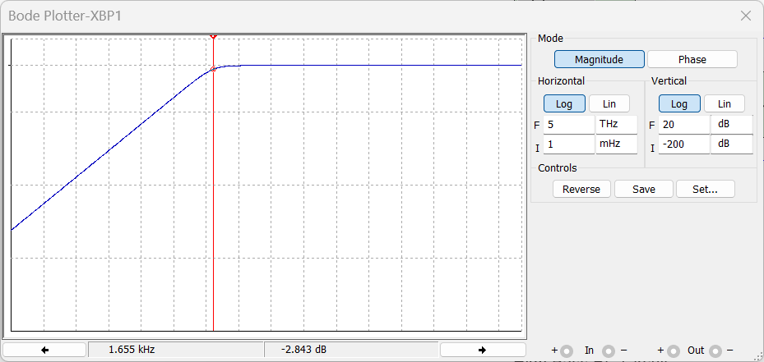

**Conclusion:**

From the above response we can conclude that for frequencies less than the cutoff frequency, the i/p signal is attenuated and for high frequencies the same i/p signal appeats at the o/p terminal.

**Low Pass RC Circuit**

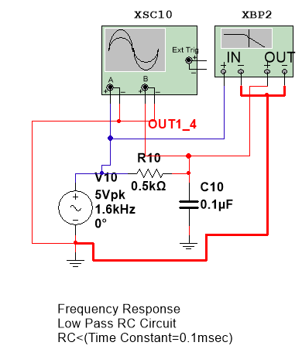

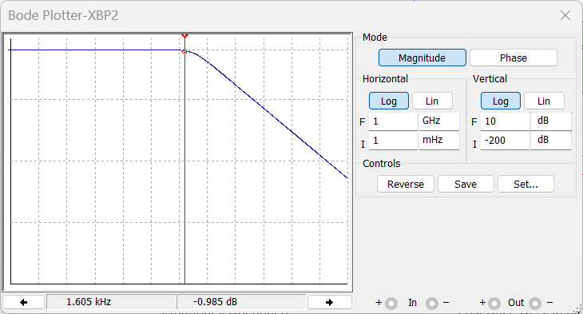

**Conclusion:**

From the above response we can conclude that for frequencies greater than the cutoff frequency, the i/p signal is attenuated and for low frequencies the same i/p signal appeats at the o/p terminal.

1. **Simulation Observations:**
2. **High Pass RC Circuit:**

**For RC<τ**

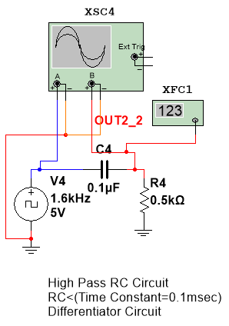

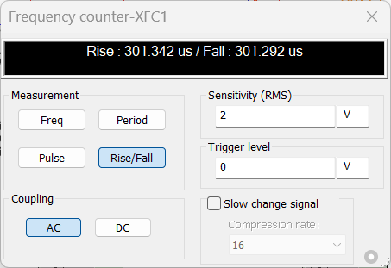

**Waveforms**:

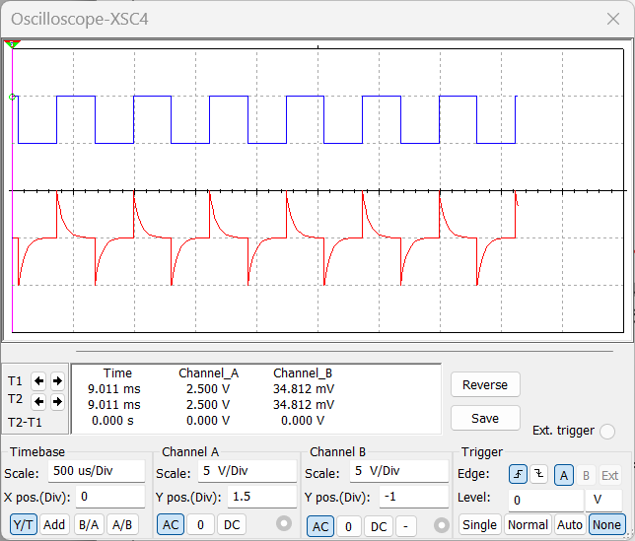

Vout

Vin

**Conclusion:**

The above waveform depicts the differentiator behaviour of RC Circuit, as we can see the input square wave is modified and produced high frequency spikes at its output. . Here RC time constant is very small, so the charging/discharging of capacitor takes place in a short duration of time thus producing spikes at high Frequencies. As we decrease the RC value the sharpness of the spikes increases. Thus we can generate spikes waveform using a High pass RC Circuit operating at RC<<τ.

[High Pass RC Circuit operating at RC<<τ = Spike Signal Generator]

**For RC=τ**

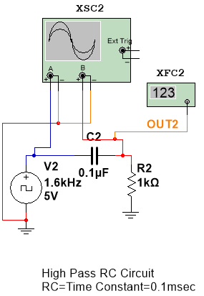

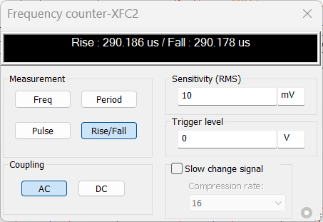

**Waveforms:**

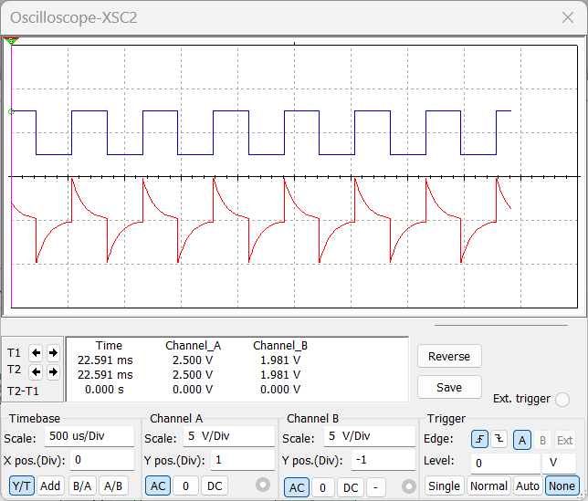

Vout

Vin

**For RC>τ**

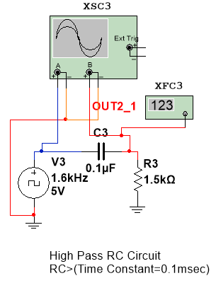

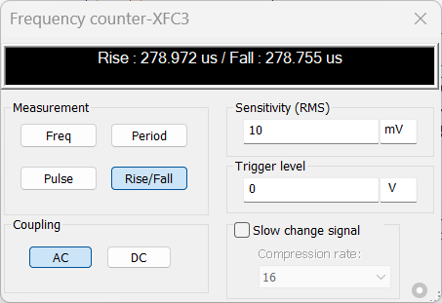

**Waveforms:**

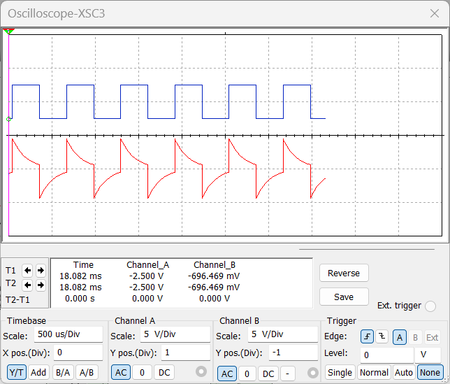

Vout

Vin

**For RC>>τ**

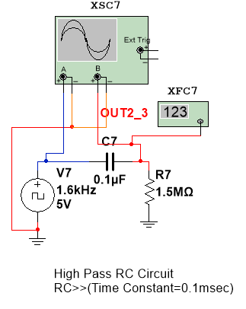

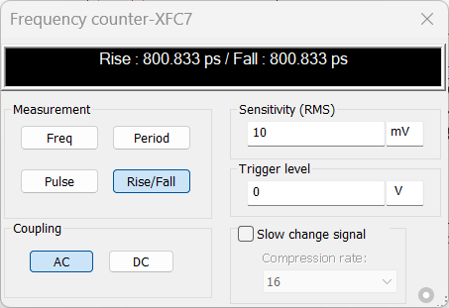

**Waveforms:**

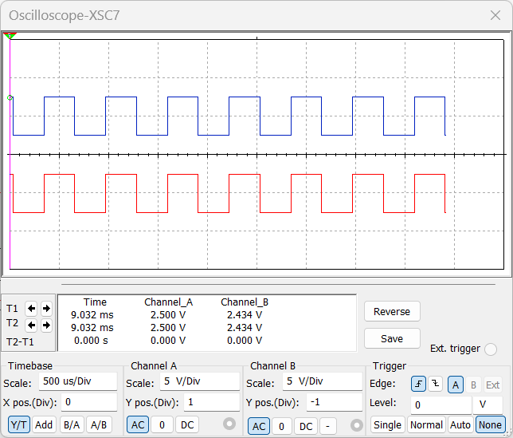

Vout

Vin

1. **Low Pass RC Circuit:**

**For RC>τ:**

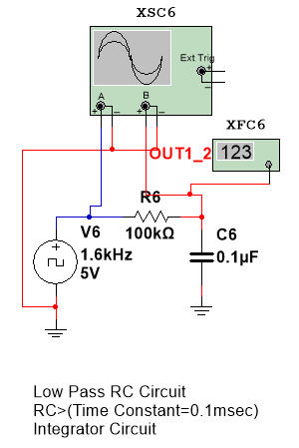

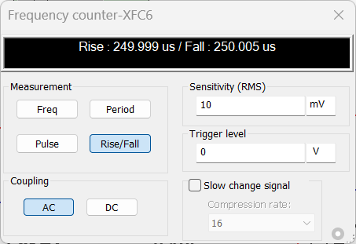

**Waveforms**:

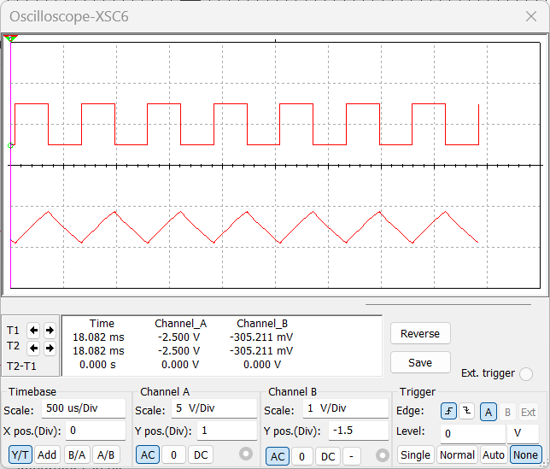

Vout

Vin

**Conclusion:**

The above waveform depicts the integrator behaviour of RC Circuit, as we can see the input square wave is modified and produced triangular waveform at its output. Here RC time constant is very large, so the charging/discharging of capacitor takes a lot of time thus producing linear increasing and decreasing graph this waveform is same as a triangular waveform. As Time constant(τ=RC) increases the triangular waveform sharpens.Thus we can generate triangular waveform using a Low pass RC Circuit perating at RC>>τ.

[Low Pass RC Circuit operating at RC>>τ = Triangular Wave Generator]

**For RC=τ**

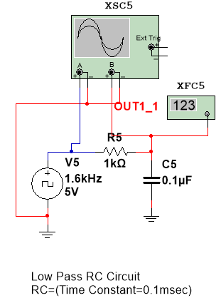

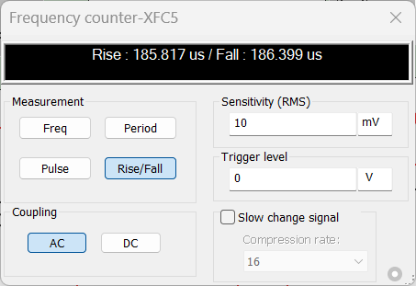

**Waveforms:**

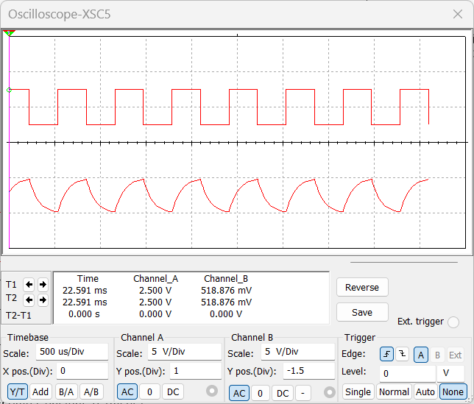

Vout

Vin

**For RC<τ**

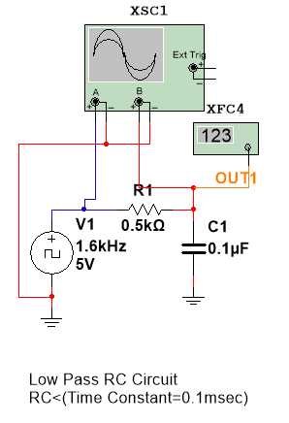

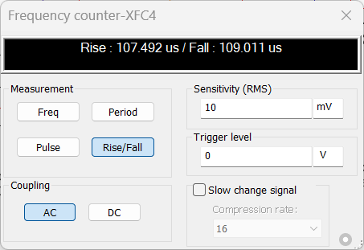

**Waveforms:**

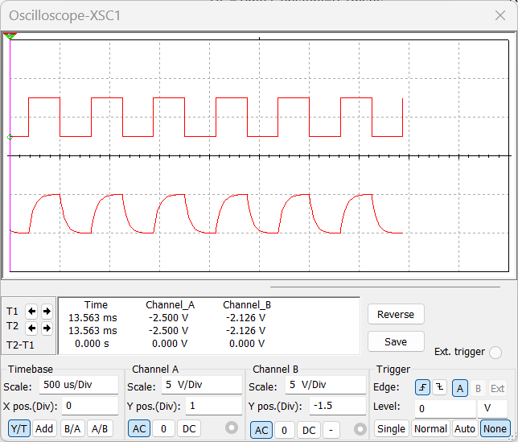

Vout

Vin

**For RC<<τ**

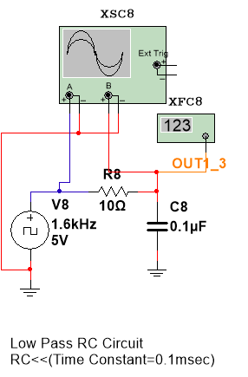

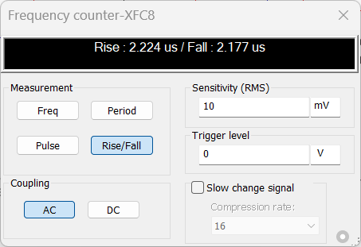

**Waveforms:**

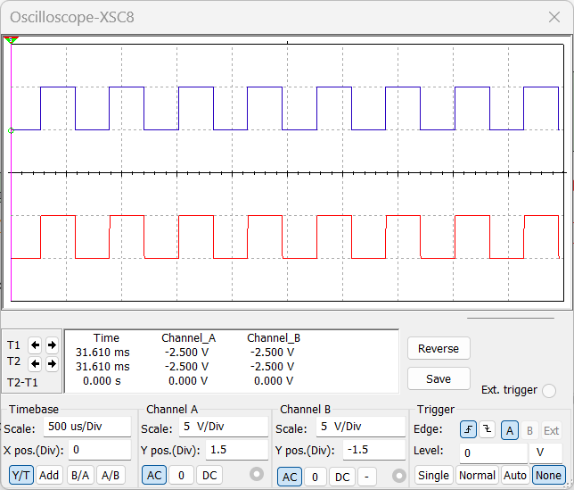

Vout

Vin

Signature of the Faculty